Roman Kutbeyev
SE-2404
Blockchain Technologies 2
Assignment 1
Part 1.
Task 1.
- Implemented ChildContract.sol with basic state.
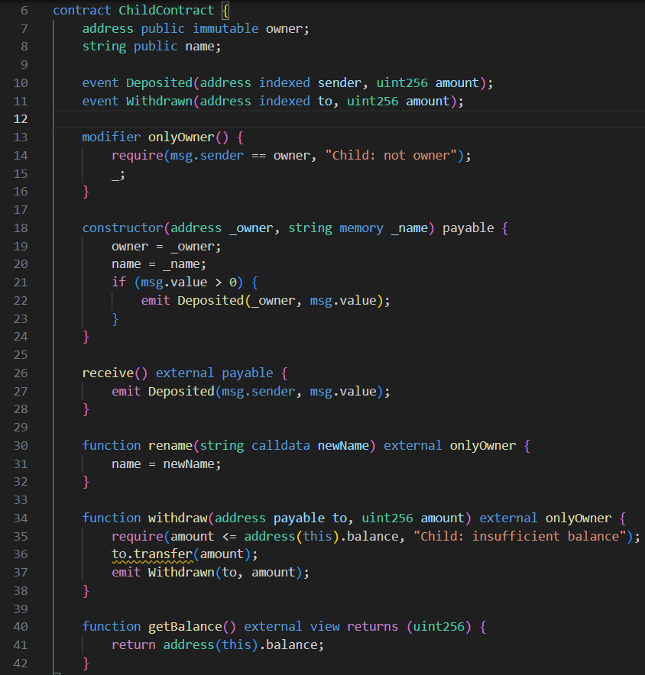
- Implemented Factory.sol which deploys ChildContract by create and create2.
  - “Create” – deploys contract by an ordinary scheme: it’s address depends on factory address and it’s nonce, so it’s hard to predict address of contract.
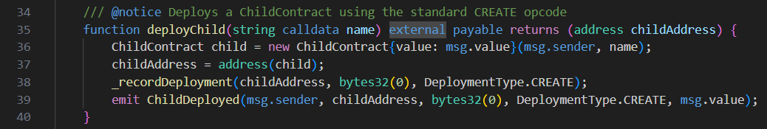
  - “Create2” – deploys contract determinably: address counts by factory + salt + bytecode and because of that it becomes real to predict accurate address of contract
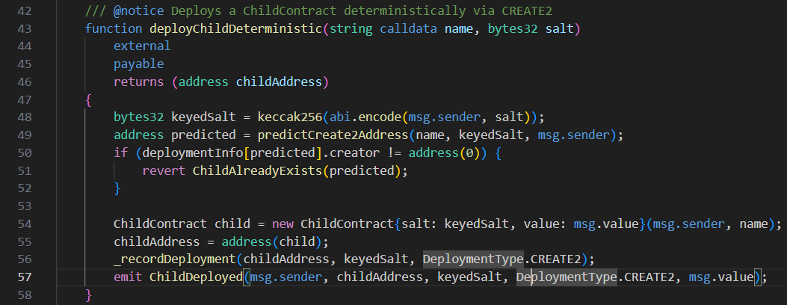
  - That is function that allows us to predict the deployment address of contract, which deploys with “Create2”
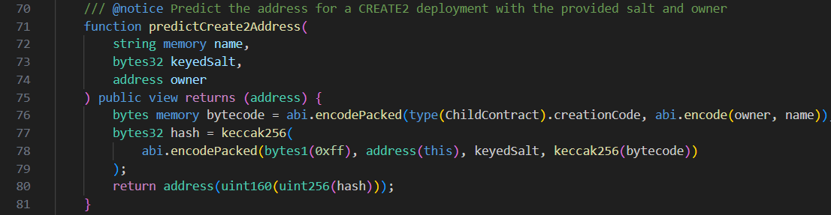
- Here we can see deployment logs:
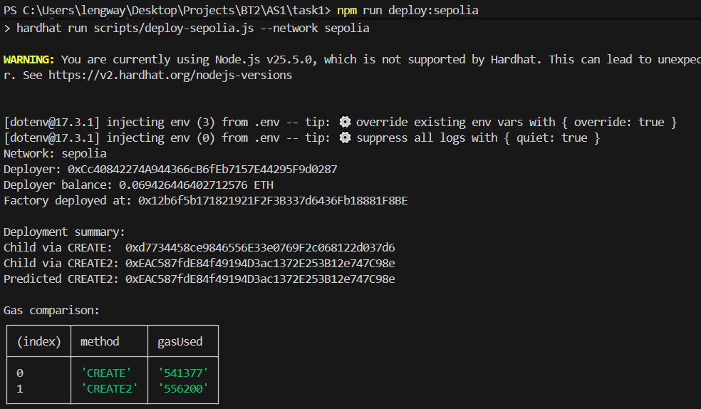
As we can see, gas is almost same, but with “Create2” we can predict address. Conclusion: “Create2” is useful when you need a predefined address (for example, for integrations, pre-funding, or meta-scenarios), while “Create” is the simple, basic approach.
Task 2.
- Implemented the first version of Logic contract – LogicV1.sol
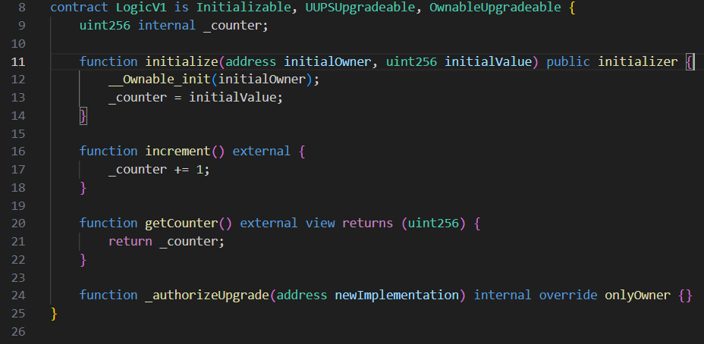
- Implemented the second version of Logic contract – LogicV2.sol as upgrade for LogicV1.sol. To the contract added decrement() function, which decrements the _counter, and the function reset(), which making _counter equals to zero.
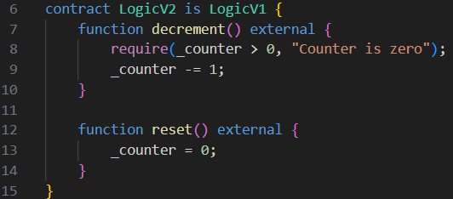
- Wrote a script that deploys LogicV1.sol contract, changes the state with increment(), upgrades it to LogicV2.sol with UUPS, checks the changed state and changing state with decrement() and reset().
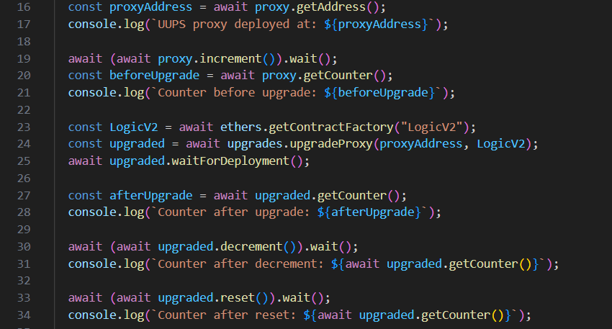
- Here we can see the results of deploying and upgrading contract.
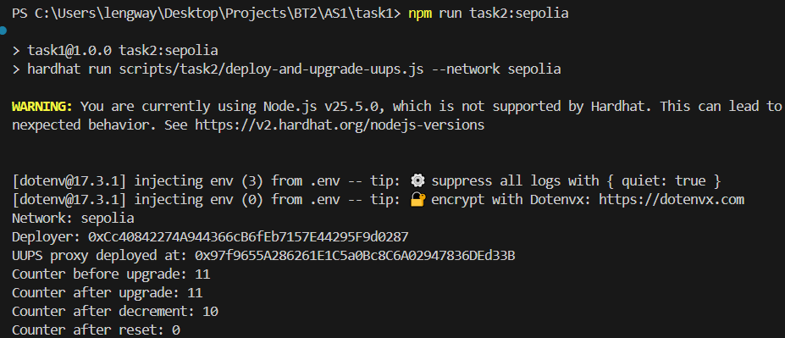
- In the UUPS pattern, users interact with a proxy contract, while logic is stored in implementation contracts (V1, V2, etc.). The proxy forwards calls using delegatecall, so code runs from the implementation, but all state is read/written in the proxy’s storage. This is why the counter value remains after upgrading from V1 to V2.
The biggest upgrade risk is storage layout corruption. If developers reorder, remove, or change existing state variables between versions, the new implementation can read wrong values from old storage slots. Safe upgrades require keeping existing variables in the same order and only appending new ones.
Constructors are not used for proxy state initialization because constructor code runs only when the implementation contract is deployed, not when the proxy is initialized. Instead, upgradeable contracts use initialize(...) with initializer protection, which is called through the proxy and writes to proxy storage exactly once.
OpenZeppelin upgradeable libraries are used to reduce security risk and implementation mistakes. Initializable enables safe one-time initialization, UUPSUpgradeable provides the upgrade mechanism, and OwnableUpgradeable restricts upgrade authorization. This combination makes upgrades safer, standardized, and easier to validate in Hardhat tests/scripts.
Part 2.
Task 3.
- Implemented an unoptimized storage computation contract
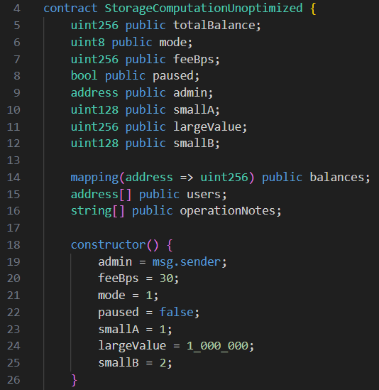
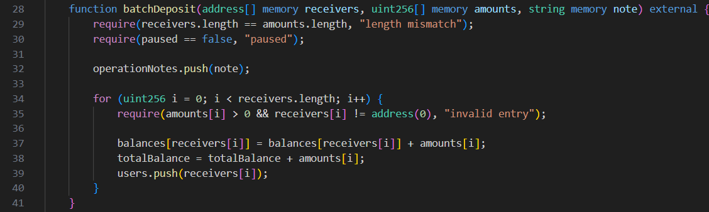
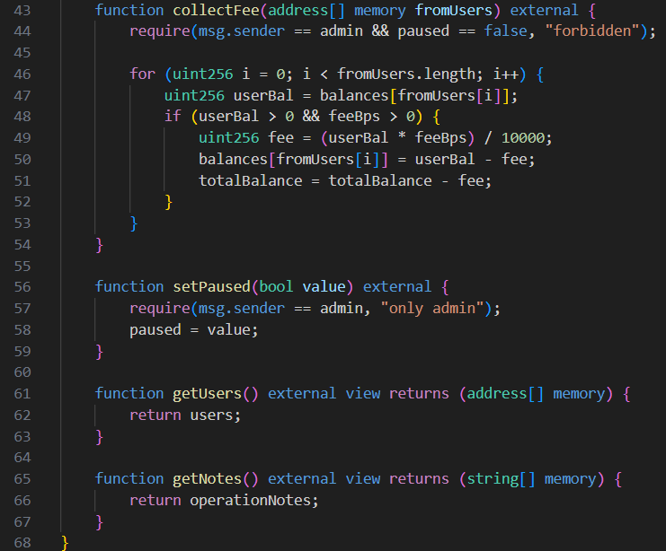
It have extra storage records, memory instead of calldata, extra memory reading, nore strings to storage instead of event
- Implemented an optimized version of same contract
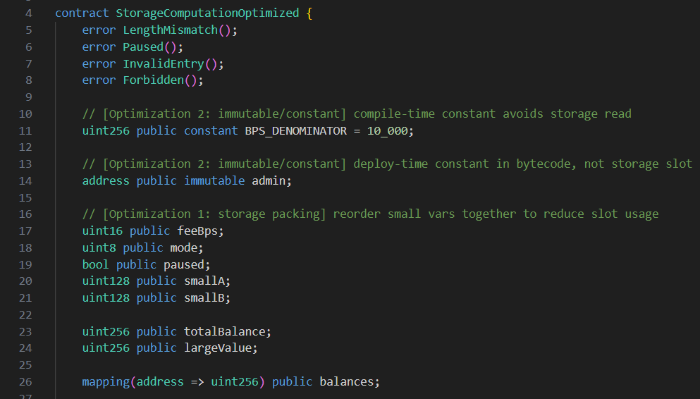
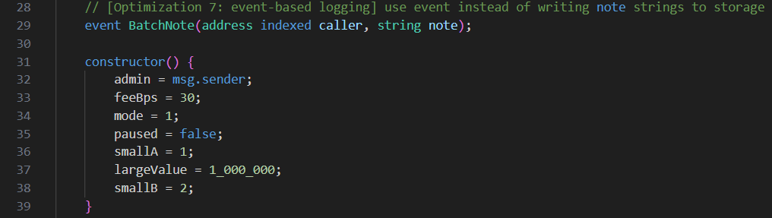
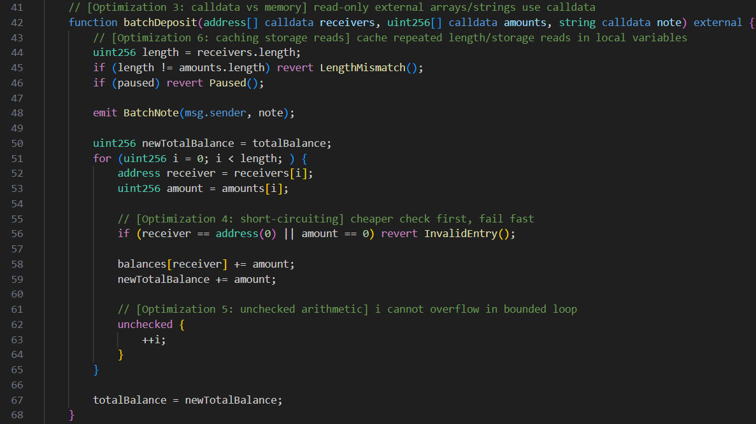
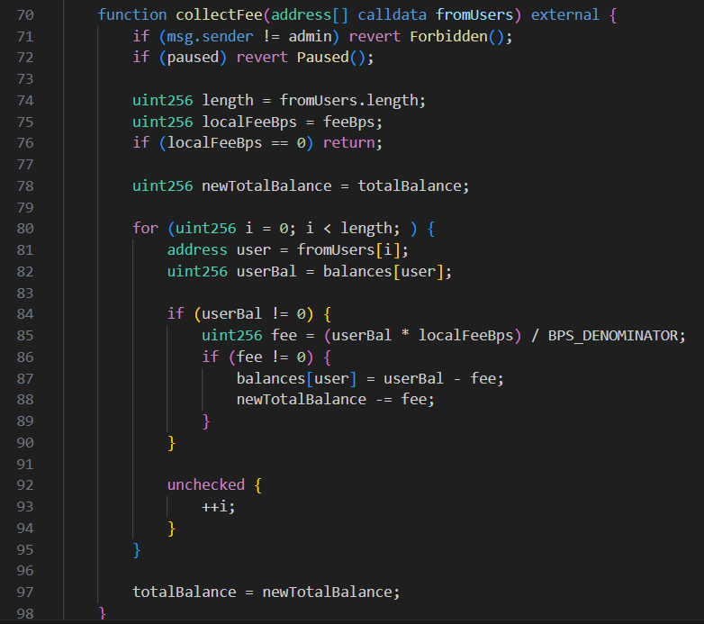
- Gas table
Operation | Unoptimized gas (avg) | Optimized gas (avg) | Gas saved | Saved %
Deployment | 1,039,509 | 578,353 | 461,156 | 44.36%
“batchDeposit” | 856,479 | 421,809 | 434,670 | 50.75%
“collectFee” | 138,268 | 127,560 | 10,708 | 7.74%
- Summary
  - Storage packing – Reordered “feeBps”, “mode”, “paused”, “smallA”, “smallB” in optimized contract -> packs smaller variables into fewer storage slots, reducing SSTORE/SLOAD cost.
  - Immutable/constant – Set “admin” as immutable and “BPS_DENOMINATOR” as constant -> avoids runtime storage reads for values fixed at deploy/compile time.
  - Calldata vs memory – Changed external read-only parameters in “batchDeposit” and “collectFee” from memory to calldata -> avoids unnecessary memory allocation and copying.
  - Short-circuiting (fail fast) – Used early checks such as “if (receiver == address(0) || amount == 0)” and early auth/paused guards -> fails earlier on invalid input and avoids extra computation/storage work.
  - Unchecked arithmetic – Used unchecked increment for loop counter (“++i”) in bounded loops -> removes redundant overflow checks where overflow is impossible.
  - Caching storage reads – Cached “length”, “feeBps”, and “totalBalance” in local variables before/inside loops -> reduces repeated expensive SLOAD operations and unnecessary storage updates.
  - Event-based logging – Replaced note storage write (“operationNotes.push(note)”) with event emission (“BatchNote”) -> LOG operations are cheaper than persistent storage writes for audit-trail data.
Task 4.
- Implemented a contract with two version (Solidity, Yul) of doing the same: captureCaller(), isPowerOfTwo(), setStoredNumber(), getStoredNumber().
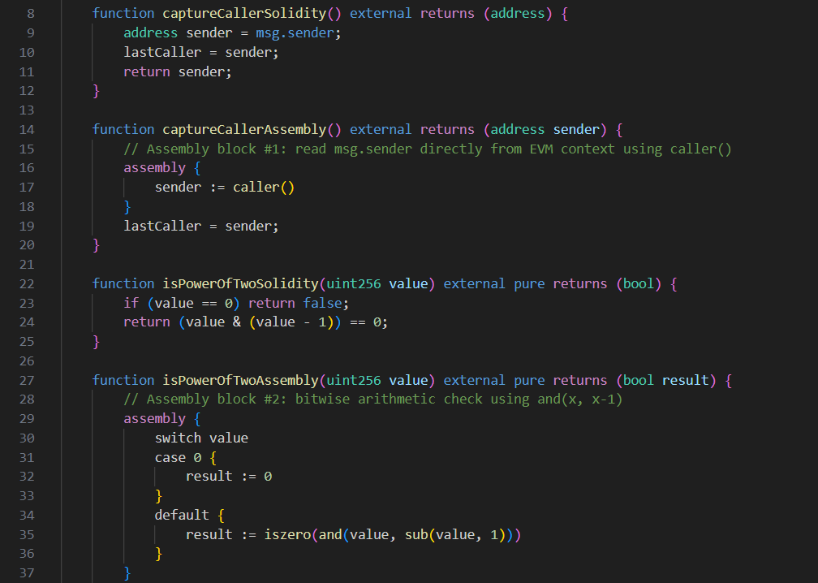 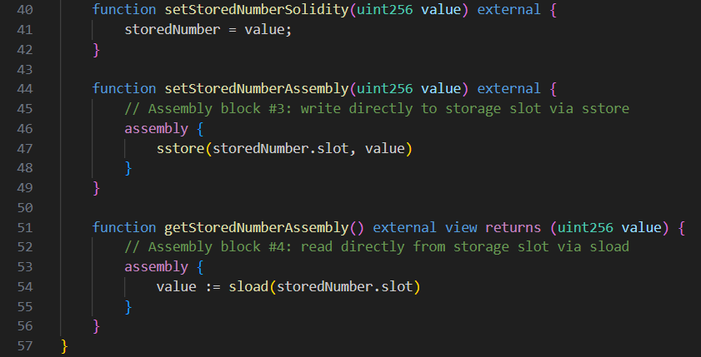
- Gas comparision:
Operation | Solidity | Assembly (Yul) | Saved Percent
captureCaller() | 43461 | 23539 | 45,84%
isPowerOfTwo() | 21653 | 21580 | 0,34%
setStoredNumber() | 43439 | 23682 | 45,61%
- Summary
Inline assembly is used for low-level EVM control: optimizing hot paths, handling byte-level logic, and accessing opcodes like caller, sstore, and sload. It can reduce gas, but its main benefit is precise execution control.
It should be used selectively. Solidity is already well-optimized and much easier to maintain, so assembly is rarely justified outside critical sections.
The main risks are safety and readability: it’s easy to introduce bugs in memory, stack, or storage, and auditing/debugging becomes harder—especially in upgradeable contracts.
Best practice: write in Solidity first, profile, then optimize only bottlenecks with small, well-documented assembly blocks covered by tests.
Part 3.
Task 5.
- Vault Vulnerability
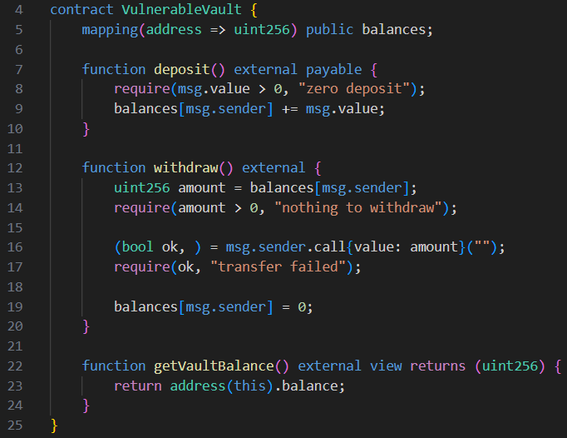
Vulnerability of this contract – reentrancy. Firstly, transfer completes and only after transfer state of balance changes. Attacker calls for a transfer, he gets gund and calls for it again, before balance changes.
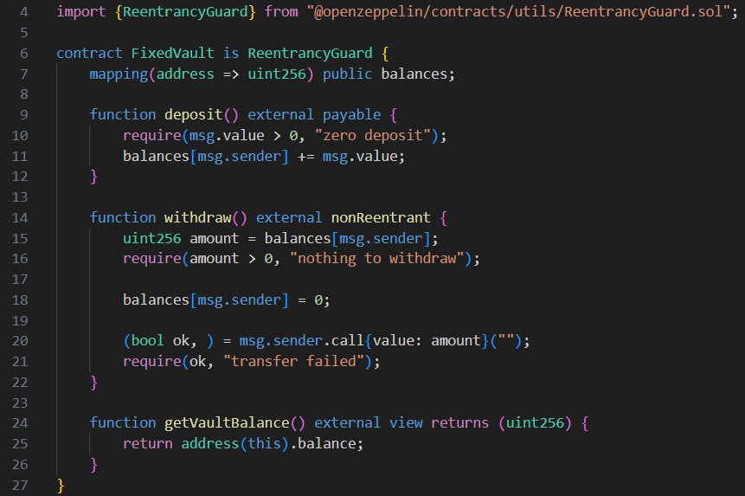
Fixed vault is protected by “ReentrancyGuard” module from OpenZeppelin library and by a different logic. ReentrancyGuard makes transfer impossible if transfer is already provided. Instead of changing balance after a transfer, this contract firstly changes the balance and then transfers funds.
- Access vulnerability
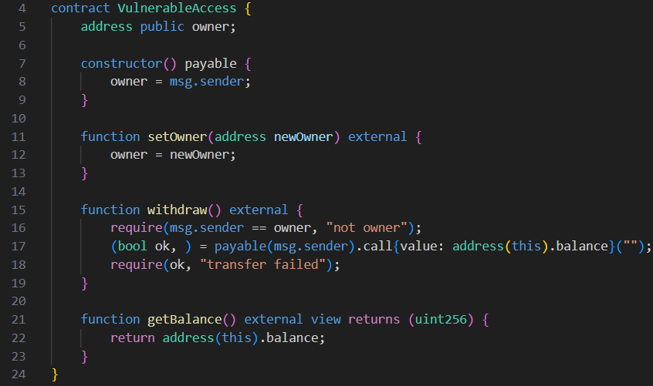
Vulnerability of this contract lies in setOwner() function: everyone can set themselves as an owner, then withdraw all funds.
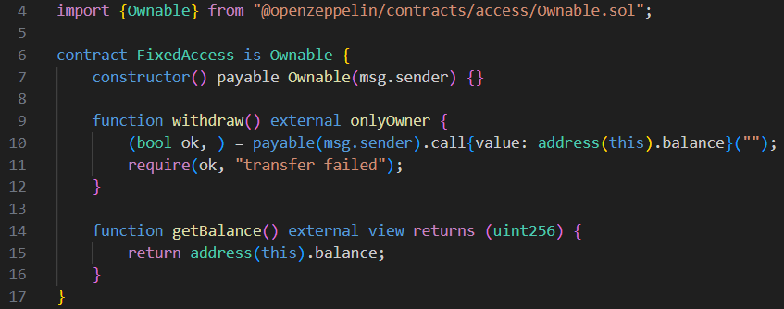
Contract fixes by “Ownable” module from OpenZeppelin library. Now owner sets by deploy and critical functions is marked by “external onlyOwner”, so non-owner cannot call these functions.
- Tests:
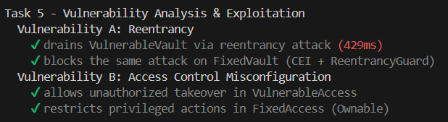
Task 6.
Severity | Before | After
High | 2 | 0
Medium | 0 | 0
Low | 6 | 5
Informational | 16 | 16
Optimization | 11 | 11
- Findings
- High/Medium findings triage
Severity | Detector | Location | Risk | TP/FP | Action
High | `reentrancy-eth` | `contracts/task5/VulnerableVault.sol::withdraw()` | External call before state update allowed recursive withdrawals and potential fund drain. | TP | Fixed: applied CEI (`balances[msg.sender]=0` before call)
High | `arbitrary-send-eth` | `contracts/task5/Attacker.sol::collect(address)` | Anyone could redirect full contract balance to arbitrary address | TP | Fixed: added owner check and zero-address validation
Medium |  | No medium-severity findings reported by Slither in baseline scan.
Part 4.
Task 7.
- Transparent Proxy, UUPS, and Diamond (EIP-2535) all separate persistent state from executable logic, but they optimize for different priorities. In the Transparent pattern, a dedicated proxy stores all state and forwards calls via `delegatecall`, while an admin account is blocked from reaching implementation functions to avoid selector clashes. In UUPS (EIP-1822 + ERC1967 slots), the upgrade logic is moved into the implementation itself, and the proxy is slimmer. Diamond generalizes this further by routing selectors to multiple facets, allowing a single contract address to expose a large modular surface area that can evolve per function rather than per monolithic implementation. This architectural difference has direct consequences for complexity, gas, and governance design.

Storage collision risk exists in all upgradeable architectures, but the risk profile differs. Transparent and UUPS typically mitigate collisions through standardized storage slots (ERC-1967) and strict storage-layout discipline across versions. In practice, the biggest failure mode is not random slot overlap but bad upgrade hygiene: reordering variables, changing inheritance trees, or introducing packed-layout assumptions that break older state. Diamond introduces an additional layer of risk because many facets share one storage context; this usually requires explicit namespaced storage structs (often called "diamond storage") and stricter code-review standards to avoid facet-to-facet collisions. So, collision risk is lowest when teams enforce deterministic storage conventions and automated layout diff checks in CI.

Gas overhead has two dimensions: deployment/upgrade cost and runtime dispatch cost. Transparent proxies generally incur slightly higher admin-path complexity and larger proxy bytecode, but user-call overhead is predictable. UUPS is often cheaper for deployment and upgrades because the proxy is minimal and upgrade logic lives in implementation code only when needed. Diamond can reduce redeployment costs for very large systems because you upgrade only affected facets, but selector routing and multi-facet indirection add conceptual and operational overhead; gas impact depends heavily on facet granularity and call patterns. For small-to-medium protocols with infrequent upgrades, UUPS usually provides the best cost-to-complexity balance.

Upgrade governance differs significantly. Transparent proxies are commonly paired with a ProxyAdmin and timelocked multisig, giving very explicit separation between business logic and upgrade authority. UUPS requires careful authorization inside `_authorizeUpgrade`, so governance mistakes become code-level mistakes; this is powerful but easier to misconfigure if review quality is weak. Diamond governance is the most flexible and the most governance-heavy: teams must govern facet cuts, selector replacement rules, rollback strategy, and facet ownership boundaries. As governance complexity grows, so does the need for formal change-management, staged rollouts, and emergency pause procedures.

Choice by context: choose Transparent when operational clarity and conservative governance are top priorities (common in enterprise or regulated deployments); choose UUPS for modern DeFi systems that want lower overhead and clean OpenZeppelin-based upgrade workflows (many ERC-1967/UUPS production deployments use this path); choose Diamond when building very large, long-lived, modular systems with many feature domains and a need to upgrade components independently. Real-world references include OpenZeppelin’s widely used Transparent and UUPS implementations, and Aavegotchi’s production use of the EIP-2535 Diamond standard. The key principle is organizational maturity: the more flexible the proxy model, the more disciplined the team’s engineering and governance process must be.
- A practical way to map DeFi risk is to start with recurring vulnerability classes and then layer protocol-specific economics on top. Five common classes repeatedly seen in production incidents align well with SWC Registry categories: reentrancy (SWC-107), broken access control (SWC-105), integer arithmetic issues (SWC-101, historically critical pre-Solidity 0.8), unchecked low-level call results (SWC-104), and transaction-ordering/front-running exposure (SWC-114). Although DeFi has evolved beyond early Solidity pitfalls, these classes remain foundational because composability amplifies small coding errors into system-level failures.

Reentrancy (SWC-107) is still the canonical DeFi bug because it exploits control-flow assumptions. Any external interaction before internal state finalization can open recursive execution paths, especially in vaults, AMMs, and callback-enabled integrations. Modern defenses combine Checks-Effects-Interactions, reentrancy guards, pull-payment patterns, and invariant-oriented testing. Importantly, cross-function and cross-contract reentrancy are now as relevant as single-function forms, so threat modeling must include all external hooks and token standards with callbacks.

Access control (SWC-105) remains another top source of catastrophic losses. In DeFi, authority is often distributed across owner roles, guardians, timelocks, upgrade admins, or governance executors; a single missing modifier or unsafe initialization path can hand over protocol control. Integer issues (SWC-101) are less common since built-in checked arithmetic in Solidity 0.8+, but custom math libraries, `unchecked` blocks, precision loss, and decimal normalization bugs still create exploitable pricing and accounting states. Unchecked low-level calls (SWC-104) are especially dangerous in payout and bridge code, where silent failures can desynchronize balances or lock funds.

Transaction-ordering dependence (SWC-114) is economically magnified by MEV. Many DeFi strategies are profitable only because transaction sequencing can be manipulated by searchers/builders, not because the protocol has a classic memory-safety bug. This is why oracle design, slippage bounds, commit-reveal patterns, and latency-aware execution controls are now core security controls, not optional features. In other words, modern DeFi security is not only about preventing invalid state transitions; it is also about hardening economic assumptions under adversarial ordering.

Exploit economics explain why attackers invest in deep protocol research. The DAO (2016) demonstrated how a reentrancy flaw could extract ~3.6M ETH (roughly $60M at that time), triggering a chain-level social response. Wormhole (2022) showed bridge risk concentration, where signature verification/validation failures enabled minting of unbacked assets (~120k ETH, around $320M at incident time). Euler Finance (2023) highlighted composable-lending attack surfaces and flash-loan-enabled attack acceleration (about $197M initially drained, with substantial recovery later). These incidents show that impact is a function of both bug severity and protocol liquidity concentration.

Automated tools are essential but bounded. Slither excels at fast static analysis and pattern-based detector coverage in CI, giving high signal for known anti-patterns and code-quality issues. Mythril performs symbolic execution to discover deeper path-dependent bugs but can be slower and produce more triage overhead. Echidna is property-based fuzzing: it is strongest when teams write meaningful invariants and adversarial state-transition properties. None of these tools can independently validate business logic correctness, governance assumptions, or economic game theory; manual auditing and protocol-specific modeling are still indispensable.

A professional security development lifecycle should be continuous, not audit-at-the-end. A strong model includes: secure design review and threat modeling before coding; strict coding standards and upgrade/storage policies; mandatory static analysis + fuzz/property tests in CI; pre-deployment internal review plus independent external audit; staged rollout with caps, timelock, and kill-switch controls; and post-deployment monitoring with on-chain alerting, bug bounty, and incident runbooks. Security sign-off should require both technical and economic invariants, with explicit acceptance of residual risks by governance. In mature teams, this lifecycle is embedded into release engineering, so each upgrade is treated as a new security-critical deployment.

GitHub link - https://github.com/lengway/BT2AS1.git

